Mini UPS 12V AC-DC Power Backup System for Routers

- Introduction
A stable internet connection is essential for online classes, remote work, communication, and entertainment. However, during power outages, routers immediately shut down, causing internet interruptions. This is especially common in the Philippines, where power interruptions frequently occur. Commercial UPS systems are often expensive or oversized for small devices such as routers. This project aims to design a compact and affordable UPS system that can continuously power routers during outages, ensuring uninterrupted internet connectivity.

II. Problem Statement
This project seeks to answer the following questions:
- How can internet connectivity be maintained during power outages?
- How can a low-cost UPS system be developed for routers?
- How can rechargeable batteries provide reliable backup power?

III. Objectives
- To develop a portable UPS system that provides backup power for routers during outages.
- To maintain stable internet connectivity during emergencies or interruptions.
- To reduce potential damage to routers caused by sudden power loss or voltage fluctuations.
- To improve convenience for students, remote workers, and households relying on internet access.

IV. Scope and Limitations

Scope
- Designed for routers and modems
- Uses rechargeable batteries
- Provides temporary backup power during outages

Limitations
- Limited runtime depending on battery capacity
- Not designed for high-power appliances

V. Significance of the Study
This project helps students, workers, and households maintain internet access during unexpected power interruptions. By providing a low-cost and compact solution, it ensures that daily activities that depend on internet connectivity such as online learning, remote work, and communication remain unaffected during power outages.

VI. Related Systems
- Commercial mini UPS devices
- Power banks with DC output
- Traditional UPS systems

VII. Methodology

Planning Phase
Research router power requirements and battery options.

Design Phase
Design the UPS circuit using the following components:
- 18650 batteries
- 3S BMS (Battery Management System)
- Boost converter / voltage regulator
- Charging module

Testing Phase
Test charging, discharge time, and output voltage stability under router load.

VIII. Materials Needed
- 18650 lithium-ion batteries
- 3S Battery Management System (BMS)
- Boost converter / voltage regulator
- Charging adapter
- Router (for testing)
- Wires and connectors
- Soldering materials

IX. Expected Output
A functional mini UPS system capable of continuously powering a router during power outages, providing stable voltage output and adequate backup runtime for typical home or office use.

Figure 1.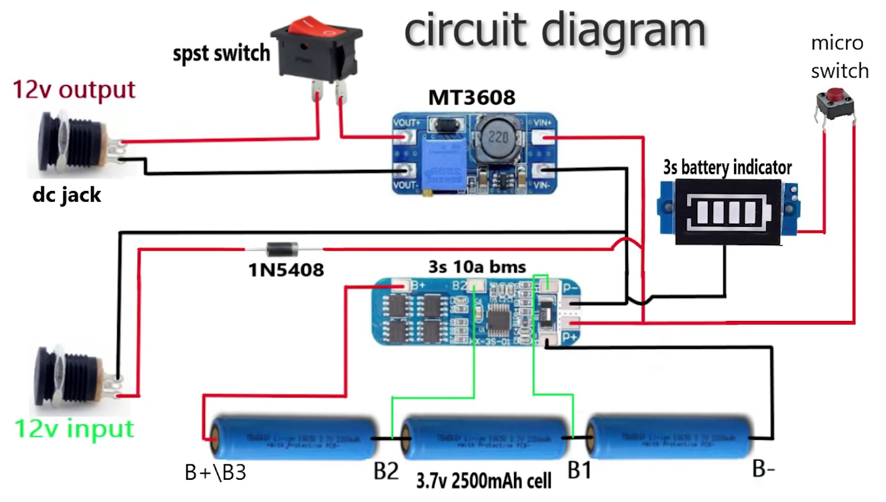

X. Calculations
For batteries connected in series:
Each 18650 battery:


Fully charged voltage:


Total Battery Energy:

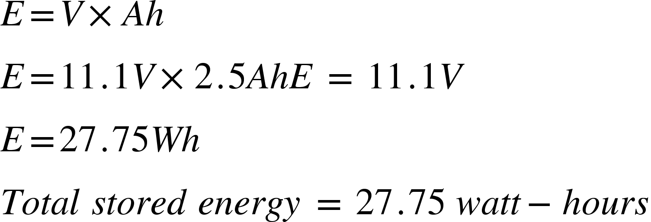

Estimated Backup Runtime:
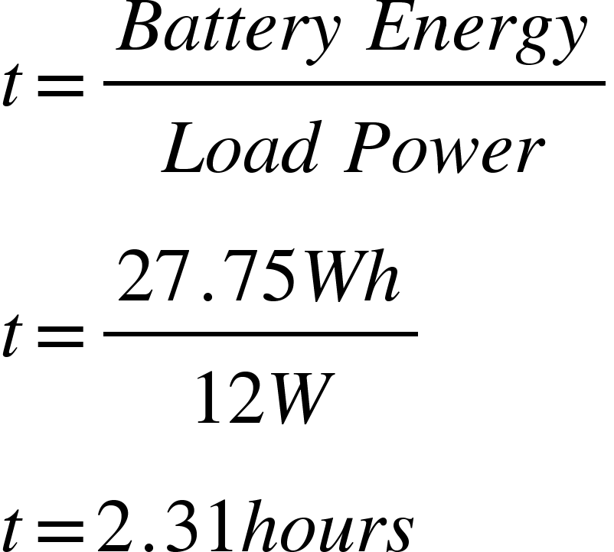
Estimated runtime:

XI. Timeline
Activity | Week 1 | Week 2 | Week 3 | Week 4
Research | ✓
Design |  | ✓
Assembly |  |  | ✓
Testing |  |  |  | ✓

XII. Budget
Item | Estimated Cost
18650 Batteries 3x | P75
Battery Management System (BMS) 1x | P30
Boost Converter / Regulator 1x | P30
Miscellaneous (wires, connectors, soldering) | P50
Total | P185

XIII. Conclusion
The project offers an affordable and practical solution for maintaining internet connectivity during power outages through a compact router UPS system. By utilizing readily available components such as 18650 batteries, a BMS, and a boost converter, this system provides a reliable and cost-effective alternative to commercial UPS devices, making it accessible to students, remote workers, and households across the Philippines.

